## EXPERIMENT NUMBER – ***4***

STUDENT’S NAME – *Yash Gupta*

STUDENT’S UID – *20BCS5009*

CLASS AND GROUP – *CSE 34B*

SEMESTER – *2nd*

## AIM OF THE EXPERIMENT –

Practical 4.1: A salesman has n things to sale. The cost price of all n things is different out of which p things he is selling on m% profit and n-p things he is going to sell on x% loss. Find his net profit or loss.

## Program –

*#include<stdio.h>*

*main(){*

*int i,n,m;*

*float p,l,profit=0,loss=0,r[3];*

*float total;*

*printf("Enter number of products =");*

*scanf("%d",&n);*

*printf("Enter products price :- ");*

*for(i=1;i<=n;i++){*

*printf("product price of %d=",i);*

*scanf("%d",&r[i]);*

*}*

*printf("\nEnter the no of items sold in the profit : ");*

*scanf("%d",&m);*

*printf("Enter the percentage of profit : ");*

*scanf("%f",&p);*

*printf("\nEnter the percentage of loss in remaining item : ");*

*scanf("%f",&l);*

*for(i=0;i<m;i++){*

*profit+=(p*r[i])/100;*

*}*

*for(i=m;i<=n;i++){*

*loss+=(l*r[i])/100;*

*}*

*total=profit-loss;*

*if(total>0){*

*printf("Profit = %d",total);*

*}else if(total<0){*

*printf("Loss = %d",total);*

*}else{*

*printf("nither profit nor loss ");*

*}*

*return 0;*

*}*

## ERRORS ENCOUNTERED DURING PROGRAM’S EXECUTION

## (Kindly jot down the compile time errors encountered)

## OUTPUT –

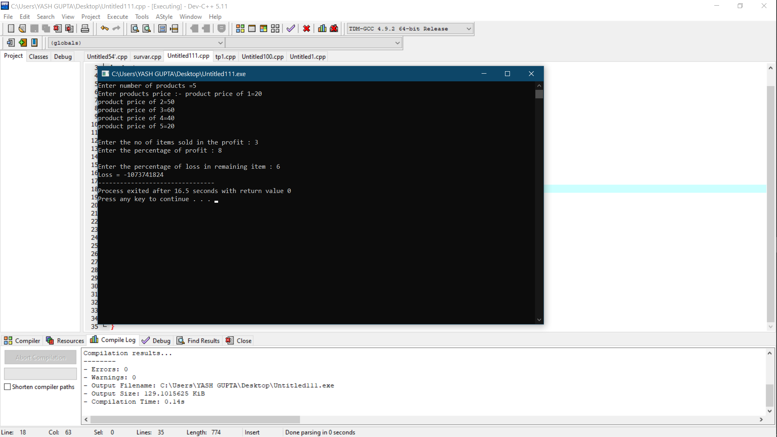

## AIM OF THE EXPERIMENT –

Practical 4.2:Find m greatest 6-digit and n smallest 7-digit numbers which are divisible by number p. Print these numbers on the screen.

## Program –

*#include <stdio.h>*

*main(){*

*int p,i;*

*printf("Enter no : ");*

*scanf("%d",&p);*

*if(p>999999)*

*printf("Not possible");*

*else*

*for(i=999999;;i--)*

*{*

*if(i%p==0)*

*{*

*printf("%d is 6-digit greatest number divisible by %d\n",i,p);*

*printf("%d is 7-digit smallest noumber divisible by %d\n",i+p,p);*

*break;*

*}*

*}*

*return 0;*

*}*

## ERRORS ENCOUNTERED DURING PROGRAM’S EXECUTION

## (Kindly jot down the compile time errors encountered)

## OUTPUT –

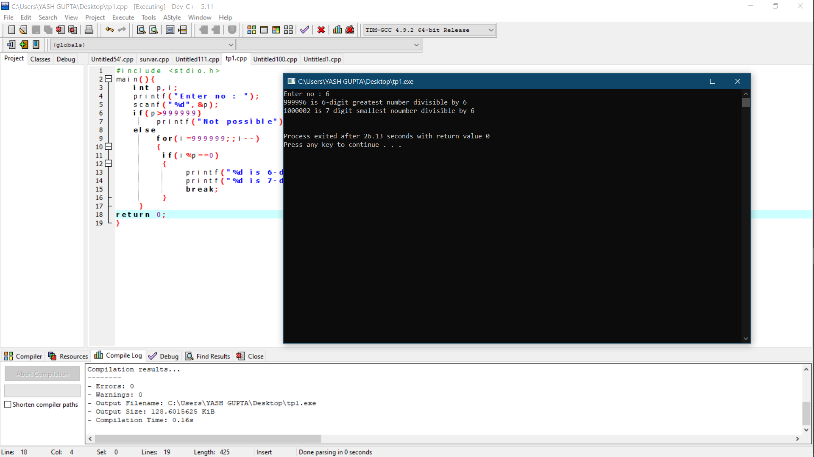

## AIM OF THE EXPERIMENT –

**Practical 4.3:** **There are n customer of bank who took loan of different amounts (Entered by User) and for different time periods but same rate of interest. The interest is compounded annually find the total interest earned by bank from all n customers.**

## ERRORS ENCOUNTERED DURING PROGRAM’S EXECUTION

## (Kindly jot down the compile time errors encountered)

## Program –

*#include <stdio.h>*

*#include <math.h>*

*main(){*

*int n,i;*

*printf("Enter no of customer : ");*

*scanf("%d",&n);*

*float principal[i],time[i],rate,interest=0;*

*printf("Enter annual rate of interest : ");*

*scanf("%f",&rate);*

*printf("Enter customer data\n");*

*for(i=0;i<n;i++)*

*{*

*printf("\nCustomer %d\n",i+1);*

*printf("Principal amount : ");*

*scanf("%f",&principal[i]);*

*printf("Time period : ");*

*scanf("%f",&time[i]);*

*}*

*for(i=0;i<n;i++)*

*{*

*interest+=principal[i]*(pow((1+(rate/(100))),time[i])-1);*

*}*

*printf("\nTotal interest earned : %f",interest);*

*return 0;*

*}*

## OUTPUT –

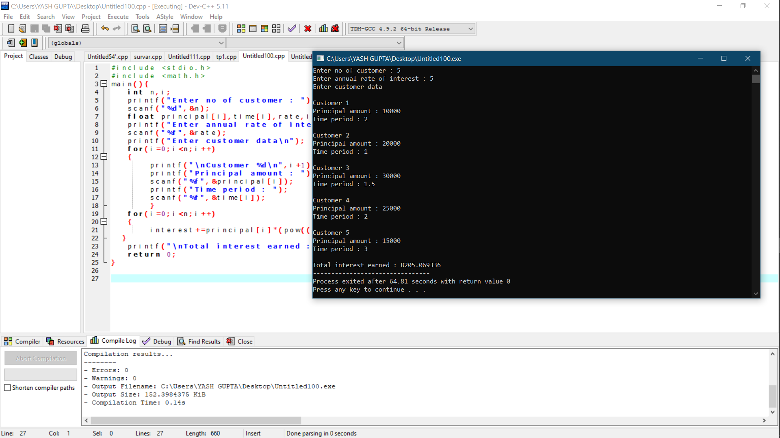

## AIM OF THE EXPERIMENT –

**Practical 4.4: On reaching the railway station, you find that the train you wanted to catch is just to start and there is hardly any time for purchasing the ticket. The same situation faced by many people in our country. You have to do data analysis task for which you will record responses from N people and then print your report accordingly. User enter option a for “Rush to train to catch it and inform T.T at next stop, b for” Catch the train and perform journey without ticket”, c for “purchase the ticket first otherwise wait for next train”, and d for “Miss the train and take ticket for next train “.On the basis of responses print in your report about the habit of our countrymen. If responses of any two options are equal then print it in either or form. If more than two responses are equal or having difference <=1 then print no conclusion drawn.**

## ERRORS ENCOUNTERED DURING PROGRAM’S EXECUTION

## (Kindly jot down the compile time errors encountered)

## Program –

*#include<stdio.h>*

*main(){*

*float first=0,second=0,third=0,forth=0;*

*int i,n,choise;*

*float s,p,d,f;*

*printf("\n\n Enter the no of people to take survey from:");*

*scanf("%d", &n);*

*for(i=1;i<=n;i++){*

*printf("Hello Sir/Ma'am\n This survey is regarding the common issue we all face,\n Many a times we get late reaching the railway station\n And face a dilemma deciding whether to get ticket first or rush to train\n So, below given are some options please fill most preferable");*

*printf("Rush to train to catch it and inform T.T at next stop = 1 \nCatch the train and perform journey without ticket = 2\n Purchase ticket first otherwise wait for next train =3\n Miss the train and take ticket for next train =4\n\n Enter your choise --> ");*

*scanf("%d",&choise);*

*if(choise>4){*

*printf("No such option exist's");*

*}*

*printf("\tThank you !!");*

*if(choise==1){*

*first++;*

*}*

*if(choise==2){*

*second++;*

*}*

*if(choise==3){*

*third++;*

*}*

*if(choise==4){*

*forth++;*

*}*

*}*

*s=(first/n)*100;*

*p=(second/n)*100;*

*d=(third/n)*100;*

*f=(forth/n)*100;*

*printf("percentage of people chooseing \n First option = %f\n Second option =%f\n Third option = %f\n Forth option =%f ",s,p,d,f);*

*return 0;*

*}*

## OUTPUT –

*Enter the no of people to take survey from:5*

*Hello Sir/Ma'am*

*This survey is regarding the common issue we all face,*

*Many a times we get late reaching the railway station*

*And face a dilemma deciding whether to get ticket first or rush to train*

*So, below given are some options please fill most preferableRush to train to catch it and inform T.T at next stop = 1*

*Catch the train and perform journey without ticket = 2*

*Purchase ticket first otherwise wait for next train =3*

*Miss the train and take ticket for next train =4*

*Enter your choise --> 1*

*Thank you !!Hello Sir/Ma'am*

*This survey is regarding the common issue we all face,*

*Many a times we get late reaching the railway station*

*And face a dilemma deciding whether to get ticket first or rush to train*

*So, below given are some options please fill most preferableRush to train to catch it and inform T.T at next stop = 1*

*Catch the train and perform journey without ticket = 2*

*Purchase ticket first otherwise wait for next train =3*

*Miss the train and take ticket for next train =4*

*Enter your choise --> 2*

*Thank you !!Hello Sir/Ma'am*

*This survey is regarding the common issue we all face,*

*Many a times we get late reaching the railway station*

*And face a dilemma deciding whether to get ticket first or rush to train*

*So, below given are some options please fill most preferableRush to train to catch it and inform T.T at next stop = 1*

*Catch the train and perform journey without ticket = 2*

*Purchase ticket first otherwise wait for next train =3*

*Miss the train and take ticket for next train =4*

*Enter your choise --> 3*

*Thank you !!Hello Sir/Ma'am*

*This survey is regarding the common issue we all face,*

*Many a times we get late reaching the railway station*

*And face a dilemma deciding whether to get ticket first or rush to train*

*So, below given are some options please fill most preferableRush to train to catch it and inform T.T at next stop = 1*

*Catch the train and perform journey without ticket = 2*

*Purchase ticket first otherwise wait for next train =3*

*Miss the train and take ticket for next train =4*

*Enter your choise --> 1*

*Thank you !!Hello Sir/Ma'am*

*This survey is regarding the common issue we all face,*

*Many a times we get late reaching the railway station*

*And face a dilemma deciding whether to get ticket first or rush to train*

*So, below given are some options please fill most preferableRush to train to catch it and inform T.T at next stop = 1*

*Catch the train and perform journey without ticket = 2*

*Purchase ticket first otherwise wait for next train =3*

*Miss the train and take ticket for next train =4*

*Enter your choise --> 1*

*Thank you !!percentage of people chooseing*

*First option = 60.000004*

*Second option =20.000000*

*Third option = 20.000000*

*Forth option =0.000000*

*--------------------------------*

*Process exited after 38.18 seconds with return value 0*

*Press any key to continue . . .*

## AIM OF THE EXPERIMENT –

**Practical 4.5: You are given task to write numbers from m to n, during this task how many times do you write digit d. e.g. if m=10 and n=25 and d=1 you write from 10 to 20 on screen and count how many times you write 1. In this case count for d=1 is 11 as from 10 to 19 you write 1, 11 times and once in 21 so total count is 12?**

## Program –

#include <stdio.h>

int main()

{

   int m,n,d,i,temp,count=0;

   printf("Enter starting no : ");

   scanf("%d",&m);

   printf("Enter last no : ");

   scanf("%d",&n);

   printf("Enter digit you want to count : ");

   scanf("%d",&d);

   for(i=m;i<=n;i++)

   {

       temp=i;

       while(temp)

       {

           if(d==(temp%10))

           count++;

           temp/=10;

       }

   }

   printf("In the given series, repetition of %d is : %d times",d,count);

return 0;

}

## ERRORS ENCOUNTERED DURING PROGRAM’S EXECUTION

## (Kindly jot down the compile time errors encountered)

## OUTPUT –

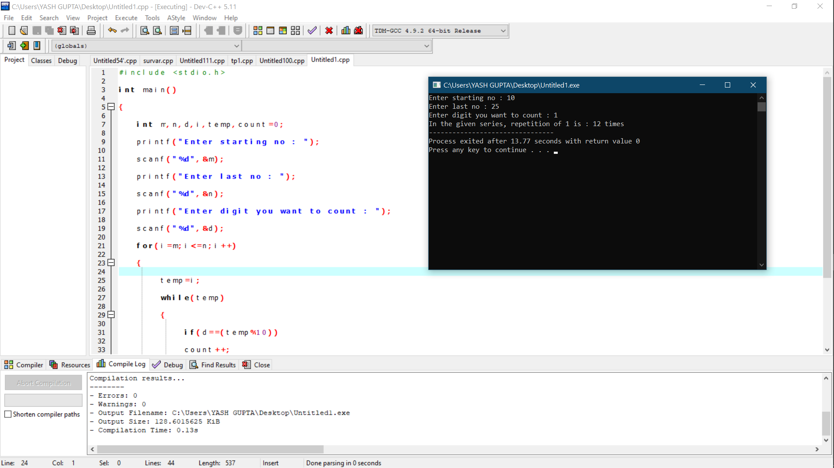

LEARNING OUTCOMES

|  |
| --- |
| * Identify situations where computational methods would be useful. |
| * Approach the programming tasks using techniques learnt and write pseudo-code. |
| * Choose the right data representation formats based on the requirements of the problem. |
| * Use the comparisons and limitations of the various programming constructs and choose the right one for the task. |

EVALUATION COLUMN (To be filled by concerned faculty only)

|  |  |  |  |
| --- | --- | --- | --- |
| **Sr. No.** | **Parameters** | **Maximum**  **Marks** | **Marks**  **Obtained** |
| 1. | Worksheet Completion including writing learning objective/ Outcome | 10 |  |
| 2. | Post Lab Quiz Result | 5 |  |
| 3. | Student engagement in Simulation/ Performance/ Pre Lab Questions | 5 |  |
| 4. | Total Marks | 20 |  |